The Curve Pen Tool Part 2

# Starting Point

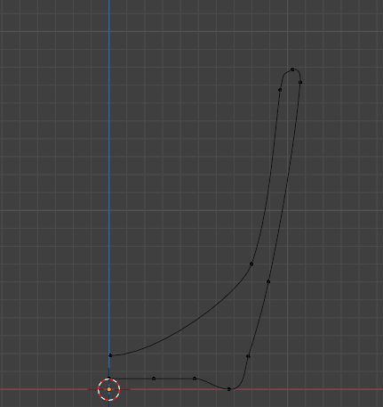

<https://www.youtube.com/watch?v=APxkUd7OAAk>

